Types of Heads
# Source: AI Source: Provided by: [Data Path: Persons Table -> ID Column: 1, Name_En Column: Motasem Essam] -> From: [Chatgpt (GPT‑5 Mini)] on [8/7/2025]
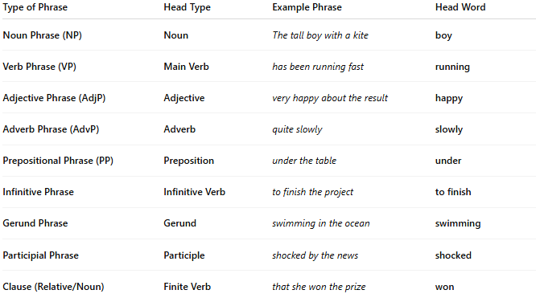
Type of Phrase | Head Type | Example Phrase | Head Word
Noun Phrase (NP) | Noun | The tall boy with a kite | boy
Verb Phrase (VP) | Main Verb | has been running fast | running
Adjective Phrase (AdjP) | Adjective | very happy about the result | happy
Adverb Phrase (AdvP) | Adverb | quite slowly | slowly
Prepositional Phrase (PP) | Preposition | under the table | under
Infinitive Phrase | Infinitive Verb | to finish the project | to finish
Gerund Phrase | Gerund | swimming in the ocean | swimming
Participial Phrase | Participle | shocked by the news | shocked
Clause (Relative/Noun) | Finite Verb | that she won the prize | won

